TEST 9
LISTENING

PART 1 Questions 1 – 7
Complete the notes below.
Write ONE WORD ONLY for each answer.

Opportunities for voluntary work in Southoe village
Library
Help with 1 …………………… books (times to be arranged)
Help needed to keep 2 …………………… of books up to date
Library is in the 3 …………………… Room in the village hall
Lunch club
Help by providing 4 ……………………
Help with hobbies such as 5 ……………………
Help for individuals needed next week
Taking Mrs Carroll to 6 ……………………
Work in the 7 …………………… at Mr Selsbury’s house

Questions 8-10
Complete the table below.
Write ONE WORD ONLY for each answer.

Village social events
Date | Event | Location | Help needed
19 Oct | 8 ……………… | Village hall | providing refreshments
18 Nov | dance | Village hall | checking 9 ………………
31 Dec | New Year’s Eve party | Mountfort Hotel | designing the 10 ………………

PART 2 Questions 11-20
Questions 11 and 12
Choose TWO letters, A-E.
What are the TWO main reasons why this site has been chosen for the housing development?
A It has suitable geographical features.
B There is easy access to local facilities.
C It has good connections with the airport.
D The land is of little agricultural value.
E It will be convenient for workers.
Questions 13 and 14
Choose TWO letters, A-E.
Which TWO aspects of the planned housing development have people given positive feedback about?
A the facilities for cyclists
B the impact on the environment
C the encouragement of good relations between residents
D the low cost of all the accommodation
E the rural location

Questions 15-20
Label the map below.
Write the correct letter, A-l, next to Questions 15-20
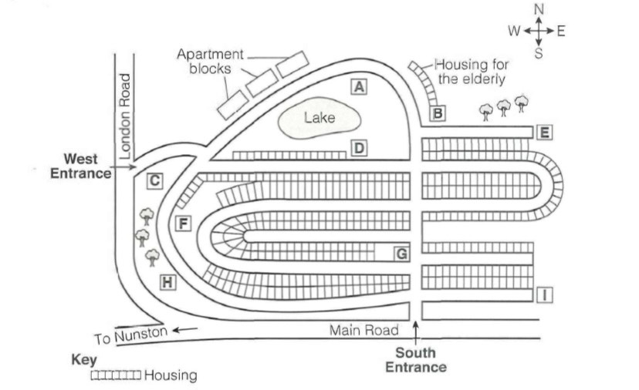
South Entrance
15 School
16 Sports centre
17 Clinic
18 Community centre
19 Supermarket
20 Playground

PART 3 Questions 21–30
Questions 21–26
Complete the notes below.
Write ONE WORD AND/OR A NUMBER for each answer.
Background on school marching band
It consists of around 21 .............................. students.
It is due to play in a 22 .............................. band competition.
It has been invited to play in the town's 23 .............................. .
They have listened to a talk by a 24 .............................. .
Joe will discuss a 25 .............................. with the band.
Joe hopes the band will attend a 26 .............................. next month.

Questions 27–30
What problem does Joe mention in connection with each of the following band members?
Choose FOUR answers from the box and write the correct letter, A–F, next to Question 27–30.
Problems
A | makes a lot of mistakes in rehearsals
B | keeps making unhelpful suggestions
C | has difficulty with rhythm
D | misses too many rehearsals
E | has a health problem
F | doesn't mix with other students

 | Band members
27 | flautist | ....................
28 | trumpeter | ....................
29 | trombonist | ....................
30 | percussionist | ....................
PART 4 Questions 31-40
Complete the notes below.
Write ONE WORD ONLY for each answer.

Early history of keeping clean
Prehistoric times:
• water was used to wash off 31
Ancient Babylon:
• soap-like material found in 32 cylinders
Ancient Greece:
• people cleaned themselves with sand and other substances
• used a strigil - scraper made of 33
• washed clothes in streams
Ancient Germany and Gaul:
• used soap to colour their 34
Ancient Rome:
• animal fat, ashes and clay mixed through action of rain, used for washing clothes
• from about 312 BC, water carried to Roman 35 by aqueducts
Europe in Middle Ages:
• decline in bathing contributed to occurrence of 36
• 37 began to be added to soap
Europe from 17th century:
• 1600s: cleanliness and bathing started becoming usual
• 1791: Leblanc invented a way of making soda ash from 38
• early 1800s: Chevreul turned soapmaking into a 39
• from 1800s, there was no longer a 40 on soap

READING

READING PASSAGE 1
You should spend about 20 minutes on Questions 1-13 which are based on Reading Passage 1 below.

The Dead Sea Scrolls
In late 1946 or early 1947, three Bedouin teenagers were tending their goats and sheep near the ancient settlement of Qumran, located on the northwest shore of the Dead Sea in what is now known as the West Bank. One of these young shepherds tossed a rock into an opening on the side of a cliff and was surprised to hear a shattering sound. He and his companions later entered the cave and stumbled across a collection of large clay jars, seven of which contained scrolls with writing on them. The teenagers took the seven scrolls to a nearby town where they were sold for a small sum to a local antiquities dealer. Word of the find spread, and Bedouins and archaeologists eventually unearthed tens of thousands of additional scroll fragments from 10 nearby caves; together they make up between 800 and 900 manuscripts. It soon became clear that this was one of the greatest archaeological discoveries ever made.
The origin of the Dead Sea Scrolls, which were written around 2,000 years ago between 150 BCE and 70 CE, is still the subject of scholarly debate even today. According to the prevailing theory, they are the work of a population that inhabited the area until Roman troops destroyed the settlement around 70 CE. The area was known as Judea at that time, and the people are thought to have belonged to a group called the Essenes, a devout Jewish sect.
The majority of the texts on the Dead Sea Scrolls are in Hebrew, with some fragments written in an ancient version of its alphabet thought to have fallen out of use in the fifth century BCE. But there are other languages as well. Some scrolls are in Aramaic, the language spoken by many inhabitants of the region from the sixth century BCE to the siege of Jerusalem in 70 CE. In addition, several texts feature translations of the Hebrew Bible into Greek.
The Dead Sea Scrolls include fragments from every book of the Old Testament of the Bible except for the Book of Esther. The only entire book of the Hebrew Bible preserved among the manuscripts from Qumran is Isaiah; this copy, dated to the first century BCE, is considered the earliest biblical manuscript still in existence. Along with biblical texts, the scrolls include documents about sectarian regulations and religious writings that do not appear in the Old Testament.
The writing on the Dead Sea Scrolls is mostly in black or occasionally red ink, and the scrolls themselves are nearly all made of neither parchment (animal skin) or an early form of paper called ‘papyrus’. The only exception is the scroll numbered 3Q15, which was created out of a combination of copper and tin. Known as the Copper Scroll, this curious document features letters chiselled onto metal – perhaps, as some have theorized, to better withstand the passage of time. One of the most intriguing manuscripts from Qumran, this is a sort of ancient treasure map that lists dozens of gold and silver caches. Using an unconventional vocabulary and odd spelling, it describes 64 underground hiding places that supposedly contain riches buried for safekeeping. None of these hoards have been recovered, possibly because the Romans pillaged Judea during the first century CE. According to various hypotheses, the treasure belonged to local people, or was rescued from the Second Temple before its destruction or never existed to begin with.
Some of the Dead Sea Scrolls have been on interesting journeys. In 1948, a Syrian Orthodox archbishop known as Mar Samuel acquired four of the original seven scrolls from a Jerusalem shoemaker and part-time antiquity dealer, paying less than $100 for them. He then travelled to the United States and unsuccessfully offered them to a number of universities, including Yale. Finally, in 1954, he placed an advertisement in the business newspaper The Wall Street Journal – under the category ‘Miscellaneous Items for Sale’ – that read: ‘Biblical Manuscripts dating back to at least 200 B.C. are for sale. This would be an ideal gift to an educational or religious institution by an individual or group.’ Fortunately, Israeli archaeologist and statesman Yigael Yadin negotiated their purchase and brought the scrolls back to Jerusalem, where they remain to this day.
In 2017, researchers from the University of Haifa restored and deciphered one of the last untranslated scrolls. The university’s Eshbal Ratson and Jonathan Ben-Dov spent one year reassembling the 60 fragments that make up the scroll. Deciphered from a band of coded text on parchment, the find provides insight into the community of people who wrote it and the 364-day calendar they would have used. The scroll names celebrations that indicate shifts in seasons and details two yearly religious events known from another Dead Sea Scroll. Only one more known scroll remains untranslated.

Questions 1-5
Complete the notes below.
Choose ONE WORD ONLY from the passage for each answer.
Write your answers in boxes 1-5 on your answer sheet.

The Dead Sea Scrolls
Discovery
Qumran, 1946/7
three Bedouin shepherds in their teens were near an opening on side of cliff
heard a noise of breaking when one teenager threw a 1 ……………………
teenagers went into the 2 …………………… and found a number of containers made of 3 ……………………
The scrolls
date from between 150 BCE and 70 CE
thought to have been written by group of people known as the 4 ……………………
written mainly in the 5 …………………… language
most are on religious topics, written using ink on parchment or papyrus

Questions 6-13
Do the following statements agree with the information given in Reading Passage 1?
In boxes 6-13 on your answer sheet, write
TRUE if the statement agrees with the information
FALSE if the statement contradicts the information
NOT GIVEN if there is no information on this
6 The Bedouin teenagers who found the scrolls were disappointed by how little money they received for them.
7 There is agreement among academics about the origin of the Dead Sea Scrolls.
8 Most of the books of the Bible written on the scrolls are incomplete.
9 The information on the Copper Scroll is written in an unusual way.
10 Mar Samuel was given some of the scrolls as a gift.
11 In the early 1950s, a number of educational establishments in the US were keen to buy scrolls from Mar Samuel.
12 The scroll that was pieced together in 2017 contains information about annual occasions in the Qumran area 2,000 years ago.
13 Academics at the University of Haifa are currently researching how to decipher the final scroll.
READING PASSAGE 2
You should spend about 20 minutes on Questions 14-26, which are based on Reading Passage 2 below.
Living with artificial intelligence
Powerful artificial intelligence (AI) needs to be reliably aligned with human values, but does this mean AI will eventually have to police those values?
This has been the decade of AI, with one astonishing feat after another. A chess-playing AI that can defeat not only all human chess players, but also all previous human-programmed chess machines, after learning the game in just four hours? That’s yesterday’s news, what’s next? True, these prodigious accomplishments are all in so-called narrow AI, where machines perform highly specialised tasks. But many experts believe this restriction is very temporary. By mid-century, we may have artificial general intelligence (AGI) - machines that can achieve human-level performance on the full range of tasks that we ourselves can tackle.

If so, there’s little reason to think it will stop there. Machines will be free of many of the physical constraints on human intelligence. Our brains run at slow biochemical processing speeds on the power of a light bulb, and their size is restricted by the dimensions of the human birth canal. It is remarkable what they accomplish, given these handicaps. But they may be as far from the physical limits of thought as our eyes are from the incredibly powerful Webb Space Telescope.

Once machines are better than us at designing even smarter machines, progress towards these limits could accelerate. What would this mean for us? Could we ensure a safe and worthwhile coexistence with such machines? On the plus side, AI is already useful and profitable for many things, and super AI might be expected to be super useful, and super profitable. But the more powerful AI becomes, the more important it will be to specify its goals with great care. Folklore is full of tales of people who ask for the wrong thing, with disastrous consequences - King Midas, for example, might have wished that everything he touched turned to gold, but didn’t really intend this to apply to his breakfast.

So we need to create powerful AI machines that are ‘human-friendly’ - that have goals reliably aligned with our own values. One thing that makes this task difficult is that we are far from reliably human-friendly ourselves. We do many terrible things to each other and to many other creatures with whom we share the planet. If super intelligent machines don’t do a lot better than us, we’ll be in deep trouble. We’ll have powerful new intelligence amplifying the dark sides of our own fallible natures.

For safety’s sake, then, we want the machines to be ethically as well as cognitively superhuman. We want them to aim for the moral high ground, not for the troughs in which many of us spend some of our time. Luckily they’ll be smart enough for the job. If there are routes to the moral high ground, they’ll be better than us at finding them, and steering us in the right direction.

However, there are two big problems with this utopian vision. One is how we get the machines started on the journey, the other is what it would mean to reach this destination. The ‘getting started’ problem is that we need to tell the machines what they’re looking for with sufficient clarity that we can be confident they will find it - whatever ‘it’ actually turns out to be. This won’t be easy, given that we are tribal creatures and conflicted about the ideals ourselves. We often ignore the suffering of strangers, and even contribute to it, at least indirectly. How then, do we point machines in the direction of something better?
As for the ‘destination’ problem, we might, by putting ourselves in the hands of these moral guides and gatekeepers, be sacrificing our own autonomy - an important part of what makes us human. Machines who are better than us at sticking to the moral high ground may be expected to discourage some of the lapses we presently take for granted. We might lose our freedom to discriminate in favour of our own communities, for example.

Loss of freedom to behave badly isn’t always a bad thing, of course: denying ourselves the freedom to put children to work in factories, or to smoke in restaurants are signs of progress. But are we ready for ethical silicon police limiting our options? They might be so good at doing it that we won’t notice them; but few of us are likely to welcome such a future.

These issues might seem far-fetched, but they are to some extent already here. AI already has some input into how resources are used in our National Health Service (NHS) here in the UK, for example. If it was given a greater role, it might do so much more efficiently than humans can manage, and act in the interests of taxpayers and those who use the health system. However, we’d be depriving some humans (e.g. senior doctors) of the control they presently enjoy. Since we’d want to ensure that people are treated equally and that policies are fair, the goals of AI would need to be specified correctly.
We have a new powerful technology to deal with - itself, literally, a new way of thinking. For our own safety, we need to point these new thinkers in the right direction, and get them to act well for us. It is not yet clear whether this is possible, but if it is, it will require a cooperative spirit, and a willingness to set aside self-interest.

Both general intelligence and moral reasoning are often thought to be uniquely human capacities. But safety seems to require that we think of them as a package: if we are to give general intelligence to machines, we’ll need to give them moral authority, too. And where exactly would that leave human beings? All the more reason to think about the destination now, and to be careful about what we wish for.

Questions 14-19
Choose the correct letter, A, B, C or D.
Write the correct letter in boxes 14-19 on your answer sheet
14 What point does the writer make about AI in the first paragraph?
A It is difficult to predict how quickly AI will progress.
B Much can be learned about the use of AI in chess machines.
C The future is unlikely to see limitations on the capabilities of AI.
D Experts disagree on which specialised tasks AI will be able to perform.
15 What is the writer doing in the second paragraph?
A explaining why machines will be able to outperform humans
B describing the characteristics that humans and machines share
C giving information about the development of machine intelligence
D indicating which aspects of humans are the most advanced
16 Why does the writer mention the story of King Midas?
A to compare different visions of progress
B to illustrate that poorly defined objectives can go wrong
C to emphasise the need for cooperation
D to point out the financial advantages of a course of action
17 What challenge does the writer refer to in the fourth paragraph?
A encouraging humans to behave in a more principled way
B deciding which values we want AI to share with us
C creating a better world for all creatures on the planet
D ensuring AI is more human-friendly than we are ourselves
18 What does the writer suggest about the future of AI in the fifth paragraph?
A The safety of machines will become a key issue.
B It is hard to know what impact machines will have on the world.
C Machines will be superior to humans in certain respects.
D Many humans will oppose machines having a wider role.
19 Which of the following best summarises the writer’s argument in the sixth paragraph?
A More intelligent machines will result in greater abuses of power.
B Machine learning will share very few features with human learning.
C There are a limited number of people with the knowledge to program machines.
D Human shortcomings will make creating the machines we need more difficult.

Questions 20-23
Do the following statements agree with the claims of the writer in Reading Passage 2?
In boxes 20-23 on your answer sheet, write

YES if the statement agrees with the claims of the writer
NO if the statement contradicts the claims of the writer
NOT GIVEN if it is impossible to say what the writer thinks about this
20 Machines with the ability to make moral decisions may prevent us from promoting the interests of our communities.
21 Silicon police would need to exist in large numbers in order to be effective.
22 Many people are comfortable with the prospect of their independence being restricted by machines.
23 If we want to ensure that machines act in our best interests, we all need to work together.

Questions 24-26
Complete the summary using the list of phrases, A-F, below.
Write the correct letter, A-F, in boxes 24-26 on your answer sheet.
Using AI in the UK health system

AI currently has a limited role in the way 24………….are allocated in the health service. The positive aspect of AI having a bigger role is that it would be more efficient and lead to patient benefits. However, such a change would result, for example, in certain 25………….not having their current level of 26…………. . It is therefore important that AI goals are appropriate so that discriminatory practices could be avoided.
A medical practitioners
B specialised tasks
C available resources
D reduced illness
E professional authority
F technology experts

READING PASSAGE 3
You should spend about 20 minutes on Questions 27–40, which are based on Reading Passage 3 below.
The power of play
Virtually every child, the world over, plays. The drive to play is so intense that children will do so in any circumstances, for instance when they have no real toys, or when parents do not actively encourage the behavior. In the eyes of a young child, running, pretending, and building are fun. Researchers and educators know that these playful activities benefit the development of the whole child across social, cognitive, physical, and emotional domains. Indeed, play is such an instrumental component to healthy child development that the United Nations High Commission on Human Rights (1989) recognized play as a fundamental right of every child.
Yet, while experts continue to expound a powerful argument for the importance of play in children's lives, the actual time children spend playing continues to decrease. Today, children play eight hours less each week than their counterparts did two decades ago (Elkind 2008). Under pressure of rising academic standards, play is being replaced by test preparation in kindergartens and grade schools, and parents who aim to give their preschoolers a leg up are led to believe that flashcards and educational 'toys' are the path to success. Our society has created a false dichotomy between play and learning.
Through play, children learn to regulate their behavior, lay the foundations for later learning in science and mathematics, figure out the complex negotiations of social relationships, build a repertoire of creative problem-solving skills, and so much more. There is also an important role for adults in guiding children through playful learning opportunities.
Full consensus on a formal definition of play continues to elude the researchers and theorists who study it. Definitions range from discrete descriptions of various types of play such as physical, construction, language, or symbolic play (Miller & Almon 2009), to lists of broad criteria, based on observations and attitudes, that are meant to capture the essence of all play behaviors (e.g. Rubin et al. 1983).
A majority of the contemporary definitions of play focus on several key criteria. The founder of the National Institute for Play, Stuart Brown, has described play as 'anything that spontaneously is done for its own sake'. More specifically, he says it 'appears purposeless, produces pleasure and joy, [and] leads one to the next stage of mastery' (as quoted in Tippett 2008). Similarly, Miller and Almon (2009) say that play includes 'activities that are freely chosen and directed by children and arise from intrinsic motivation'. Often, play is defined along a continuum as more or less playful using the following set of behavioral and dispositional criteria (e.g. Rubin et al. 1983):
Play is pleasurable: Children must enjoy the activity or it is not play. It is intrinsically motivated: Children engage in play simply for the satisfaction the behavior itself brings. It has no extrinsically motivated function or goal. Play is process oriented: When children play, the means are more important than the ends. It is freely chosen, spontaneous and voluntary. If a child is pressured, they will likely not think of the activity as play. Play is actively engaged: Players must be physically and/or mentally involved in the activity. Play is non-literal. It involves make-believe.
According to this view, children's playful behaviors can range in degree from 0% to 100% playful. Rubin and colleagues did not assign greater weight to any one dimension in determining playfulness; however, other researchers have suggested that process orientation and a lack of obvious functional purpose may be the most important aspects of play (e.g. Pellegrini 2009).

From the perspective of a continuum, play can thus blend with other motives and attitudes that are less playful, such as work. Unlike play, work is typically not viewed as enjoyable and it is extrinsically motivated (i.e. it is goal oriented). Researcher Joan Goodman (1994) suggested that hybrid forms of work and play are not a detriment to learning; rather, they can provide optimal contexts for learning. For example, a child may be engaged in a difficult, goal-directed activity set up by their teacher, but they may still be actively engaged and intrinsically motivated. At this mid-point between play and work, the child's motivation, coupled with guidance from an adult, can create robust opportunities for playful learning.
Critically, recent research supports the idea that adults can facilitate children's learning while maintaining a playful approach in interactions known as 'guided play' (Fisher et al. 2011). The adult's role in play varies as a function of their educational goals and the child's developmental level (Hirsch-Pasek et al. 2009).
Guided play takes two forms. At a very basic level, adults can enrich the child's environment by providing objects or experiences that promote aspects of a curriculum. In the more direct form of guided play, parents or other adults can support children's play by joining in the fun as a co-player, raising thoughtful questions, commenting on children's discoveries, or encouraging further exploration or new facets to the child's activity. Although playful learning can be somewhat structured, it must also be child-centered (Nicolopolou et al. 2006). Play should stem from the child's own desire.
Both free and guided play are essential elements in a child-centered approach to playful learning. Intrinsically motivated free play provides the child with true autonomy, while guided play is an avenue through which parents and educators can provide more targeted learning experiences. In either case, play should be actively engaged, it should be predominantly child-directed, and it must be fun.

Questions 27–31
Look at the following statements (Questions 27–31) and the list of researchers below.
Match each statement with the correct researcher, A–G.
Write the correct letter, A–G, in boxes 27–31 on your answer sheet.
27 | Play can be divided into a number of separate categories.
28 | Adults' intended goals affect how they play with children.
29 | Combining work with play may be the best way for children to learn.
30 | Certain elements of play are more significant than others.
31 | Activities can be classified on a scale of playfulness.

List of Researchers
A | Elkind
B | Miller & Almon
C | Rubin et al.
D | Stuart Brown
E | Pellegrini
F | Joan Goodman
G | Hirsch-Pasek et al.

Questions 32–36
Do the following statements agree with the claims of the writer in Reading Passage 3?
In boxes 32–36 on your answer sheet, write
YES | if the statement agrees with the claims of the writer
NO | if the statement contradicts the claims of the writer
NOT GIVEN | if it is impossible to say what the writer thinks about this

32 | Children need toys in order to play.
33 | It is a mistake to treat play and learning as separate types of activities.
34 | Play helps children to develop their artistic talents.
35 | Researchers have agreed on a definition of play.
36 | Work and play differ in terms of whether or not they have a target.

Questions 37–40
Complete the summary below.
Choose ONE WORD ONLY from the passage for each answer.
Write your answers in boxes 37–40 on your answer sheet.
Guided play
In the simplest form of guided play, an adult contributes to the environment in which the child is playing. Alternatively, an adult can play with a child and develop the play, for instance by 37 .............................. the child to investigate different aspects of their game. Adults can help children to learn through play, and may make the activity rather structured, but it should still be based on the child's 38 .............................. to play.
Play without the intervention of adults gives children real 39 .............................. ; with adults, play can be 40 .............................. at particular goals. However, all forms of play should be an opportunity for children to have fun.

WRITING TASK 1
You should spend about 20 minutes on this task.

The table and charts below give information on the police budget for 2017 and 2018 in one area of Britain. The table shows where the money came from and the charts show how it was distributed.

Summarise the information by selecting and reporting the main features, and make comparisons where relevant.

Write at least 150 words.
Police Budget 2017-2018 (in £m)
Sources |  | 2017 | 2018
National Government |  | 175.5m | 177.8m
Local Taxes |  | 91.2m | 102.3m
Other sources (eg grants) |  | 38m | 38.5m
Total |  | 304.7m | 318.6m
How the money was spent
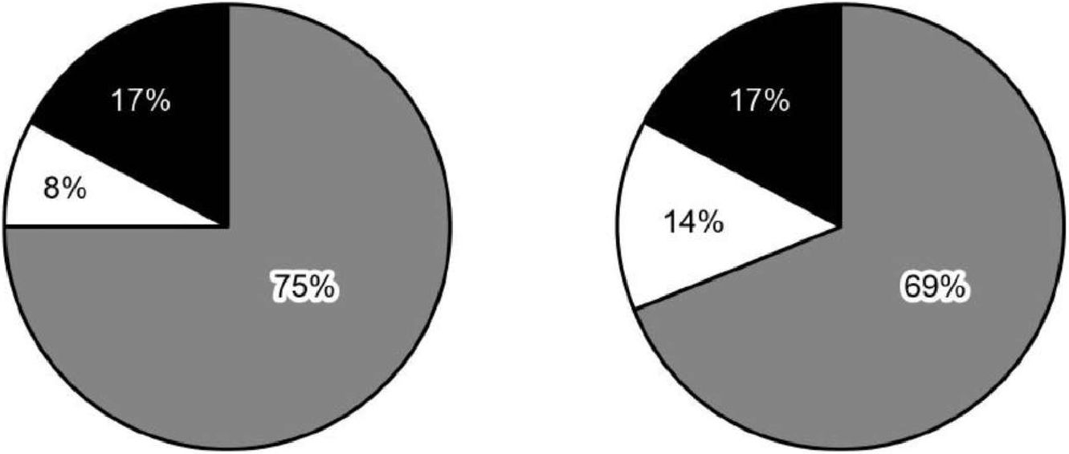
2017 2018

 | Salaries (officers and staff)
 | Technology
 | Buildings and transport

WRITING TASK 2
You should spend about 40 minutes on this task.
Write about the following topic:
Some university students want to learn about other subjects in addition to their main subjects. Others believe it is more important to give all their time and attention to studying for a qualification.
Discuss both these views and give your own opinion.
Give reasons for your answer and include any relevant examples from your own knowledge or experience.
Write at least 250 words.

SPEAKING
SPEAKING
PART 1
Reading
- Did you have a favourite book when you were a child? [Why/Why not?]
- How much reading do you do for your work/studies? [Why/Why not?]
- What kinds of books do you read for pleasure? [Why/Why not?]
- Do you prefer to read a newspaper or a magazine online, or to buy a copy? [Why?]

PART 2
You will have to talk about the topic for one to two minutes. You have one minute to think about what you are going to say. You can make some notes to help you if you wish
Describe a tourist attraction in your country that you would recommend.
You should say:
- what the tourist attraction is
- where in your country this tourist attraction is
- what visitors can see and do at this tourist attraction
and explain why you would recommend this tourist attraction.

PART 3
Discussion topics:
Museums and art galleries
1. What are the most popular museums and art galleries in ... / where you live?
2. Do you believe that all museums and art galleries should be free?
3. What kinds of things make a museum or art gallery an interesting place to visit?

The holiday industry
1. Why, do you think, do some people book package holidays rather than traveling independently?
2. Would you say that large numbers of tourists cause problems for local people?
3. What sort of impact can large holiday resorts have on the environment?

